TROOP POLICY

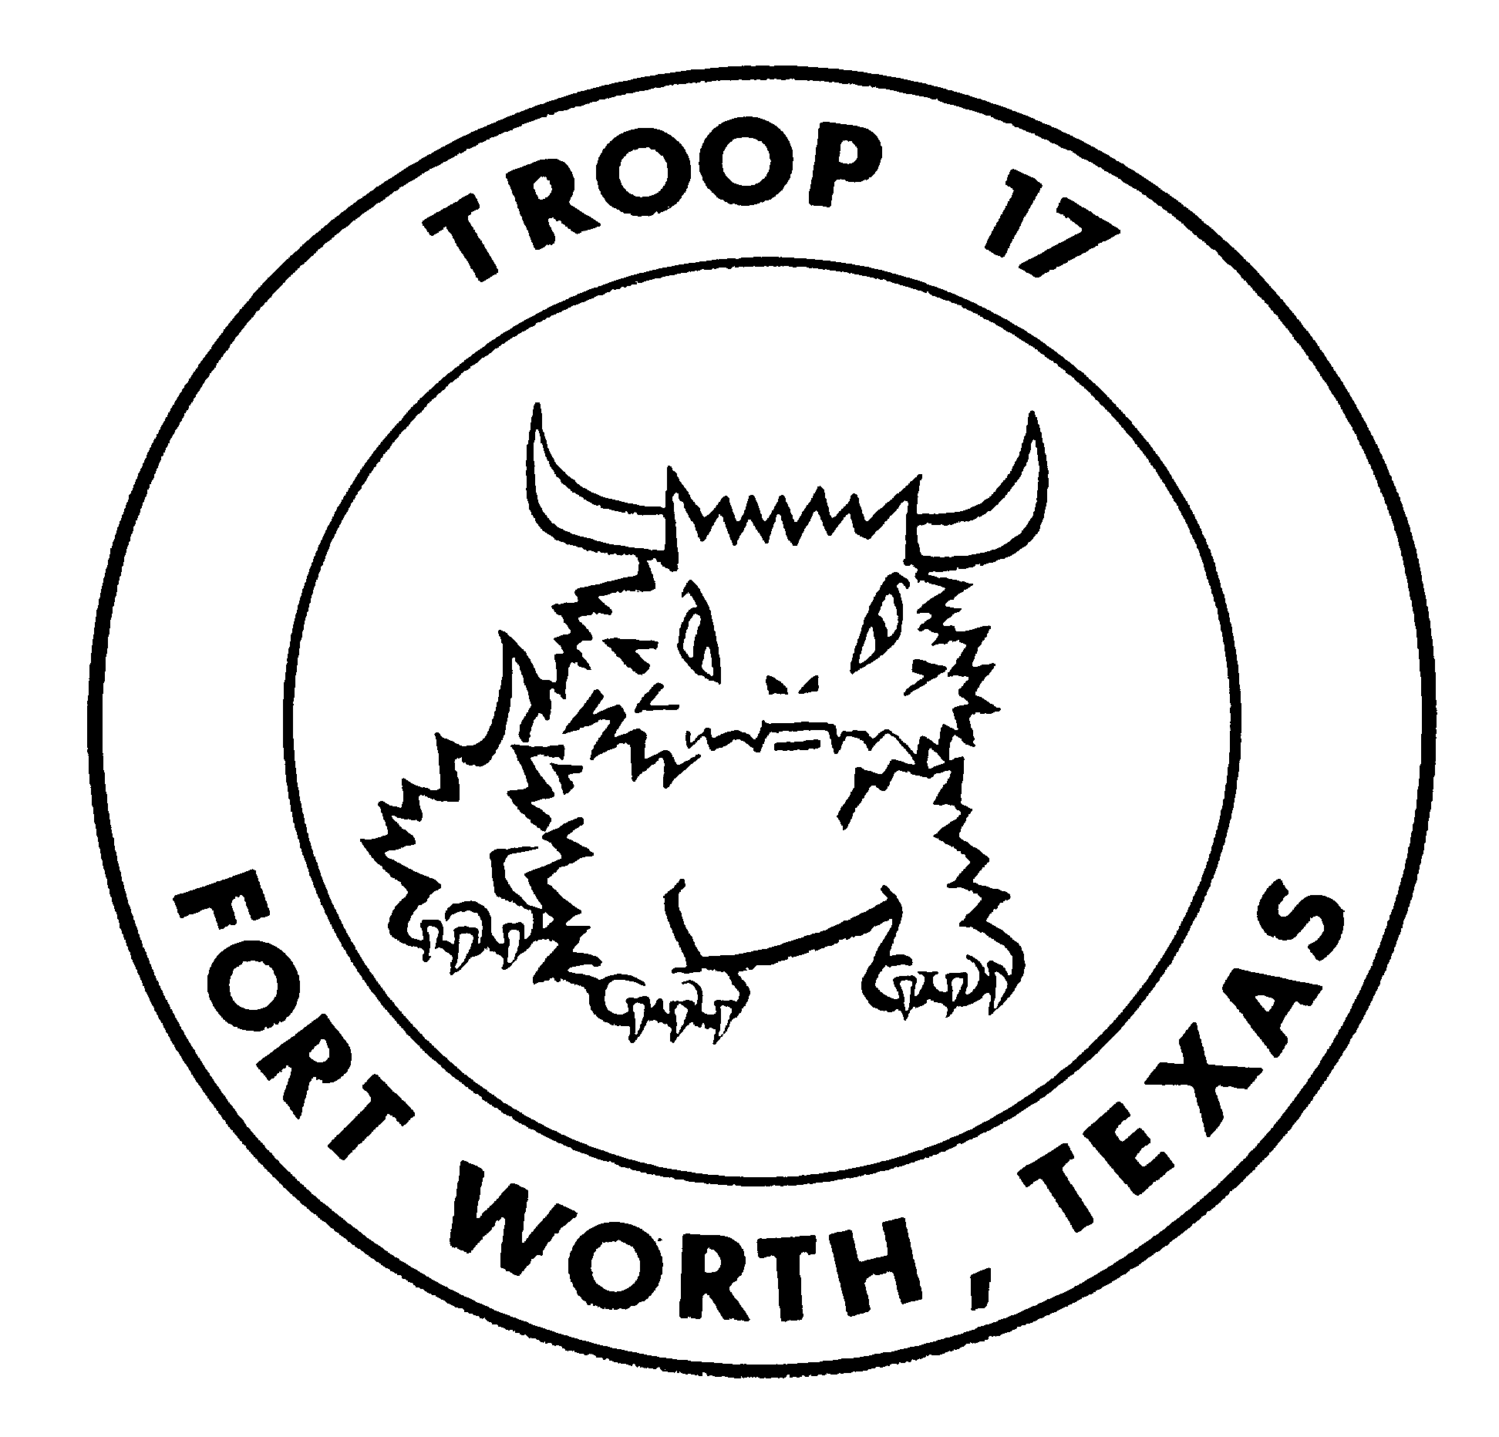

CHARTERED BY
ST STEPHEN PRESBYTERIAN CHURCH
FORT WORTH, TEXAS

Ben Harveson, SCOUTMASTER
TROOP 17 POLICY

HISTORY

Boy Scout Troop 17 was first chartered in March 1922 at the Broadway Presbyterian Church. In 1948 the church moved to its current location above Forest Park, in the TCU area, and changed its name to St. Stephen. So important was the Scout program at the church that the scout lodge was the first building completed on the new site. The lodge was paid for largely with funds raised from the sale of scrap paper, which the boys in the troop collected. Troop 17 has a long and interesting history, as one of the leading Boy Scout troops in the Fort Worth area.

PHILOSOPHY

Troop 17 is a unit of the Boy Scouts of America (BSA) under charter sponsorship of St. Stephen Presbyterian Church in Fort Worth, Texas. Troop 17 is a boy-run troop the mission of which is to offer boys in the community a program designed to accomplish the three Aims of Scouting: To Build Character, Foster Citizenship, and Encourage physical, mental and spiritual fitness. These aims are designed to be delivered through a program that stresses the acquisition of a variety of outdoor skills and also through the pursuit of a structured program in which meritorious achievement is rewarded through advancement. Above all however, the mission of Troop 17 is to ensure that Scouts have fun. In all facets of the program, the following Ideals of Scouting are emphasized:

The Scout Oath:

On my honor, I will do my best, to do my duty, to God & my country; to obey the Scout Law, to help other people at all times, to keep myself physically strong, mentally awake, and morally straight.

The Scout Law:

A Scout is Trustworthy, Loyal, Helpful, Friendly, Courteous, Kind, Obedient, Cheerful, Thrifty, Brave, Clean & Reverent.

The Scout Motto: The Scout Slogan:

Be prepared Do a good turn daily

The Wilderness Pledge:

As an American, I promise to: be clean in my outdoor manners, To be careful with fire, to be courteous in the outdoors, and be conservation-minded.
JOINING REQUIREMENTS & YEARLY DUES

Troop 17 is open to all boys who meet the requirements of the BSA, and who agree to accept, subscribe to and live by the aims and ideals described above and who agree to follow these troop policies. Upon joining, the Scout is asked to obtain a complete uniform. The troop will provide the following for each new Scout: one set troop numerals, and one troop neckerchief. Annual dues are required of all new members, and are payable upon joining. Dues for youth currently registered in the BSA who transfer in from another Cub Scout Pack or Boy Scout Troop are pro-rated for the balance of their first calendar year. Thereafter, their dues, as well as those of other existing members, are payable prior to November 31st of each year.

TROOP ORGANIZATION AND LEADERSHIP
The troop is organized into patrols each of which consists of approximately eight Scouts. Each patrol has a Patrol Leader and an Assistant Patrol Leader. The leadership structure for the troop, called the Greenbar or Patrol Leader's Council, is composed of the Senior Patrol Leader (SPL), the Assistant Senior Patrol Leader (ASPL), the Staff, the Patrol Leaders (PL) and Assistant Patrol Leaders (APL). The customary staff positions, selected by the Senior Patrol Leader and Scoutmaster, may exist as required. These positions are: Scribe, Quartermaster, Troop Guide, Instructor, Librarian, Historian, Bugler, and Chaplains Aide. Junior Assistant Scoutmasters are generally Scouts that are either 18 years of age or older or have achieved the rank of Eagle Scout. This is a position typically appointed by the Scoutmaster, with the approval of the Troop Committee.

The Greenbar is run by the SPL, and has final authority on all matters relating to troop policy and discipline. Each member has one vote, and a majority decision is binding. The Scoutmaster, Assistant Scoutmaster(s), and any Jr. Assistant Scoutmaster(s) may bring up points for discussion, but may not participate in the vote. The Scoutmaster alone has veto authority over any decision, which in his judgment, is not in the best interests of any Scout or the troop. The positions of SPL and ASPL will be appointed by the Scoutmaster.

MEETINGS

Troop 17 meets on Tuesday evenings at the St. Stephen Presbyterian Church Scout Lodge, at the corner of Sandage Ave. & McPherson Ave. streets, from 7:30 PM to 9:00 PM. Parents are asked to have their Scouts arrive at the meetings on time. The meetings will consist of a uniform inspection, patrol activities, a demonstration of a scout skill done by the SPL and the Staff, a planning period for an upcoming event, and a game. Each meeting will open with the Pledge of Allegiance, the Scout Oath, and Scout Law. Meetings close with singing of the Scout Vesper, and recitation of the Scoutmaster's benediction: "And now, may the Great Master, of all Scouts, be with us 'til we meet again."

Consistent attendance (as defined below) at troop meetings and activities in full Scout uniform is required for each Scout's advancement. The proper uniform is described in the handbook. If the Scout wears a hat, it must be a Troop 17 hat. No other hats will be permitted. A Scout may purchase a Troop 17 hat once he achieves the rank of Tenderfoot Scout.

ADVANCEMENT

Participation in at least 50% of the troop’s meetings AND 50% of all camping, service projects, and other troop activities is required for any Scout to be eligible for advancement.

The first rank, Scout, will be achieved under the direct supervision of the Scoutmaster. Achievement of the next three ranks, those of Tenderfoot, Second Class & First Class, will be primarily under the supervision of the Patrol Leader and Assistant Patrol Leader of the Scout’s patrol. The remaining three ranks, Star, Life and Eagle, involve emphasis on earning Merit Badges, and will be reviewed by the Scoutmaster, and a Board of Review consisting of members of the Troop Committee and Assistant Scout Masters.

To work on merit badges, the Scout obtains a merit badge application from the Advancement Chair and asks for the name of a counselor in that particular skill (example, Water Skiing.) The Scoutmaster or Troop Committee Member in charge of advancement will identify an approved adult merit badge counselor from the list provided by the council, and provide the Scout with his or her name and phone number. The Scout must make contact with the counselor and make arrangements to work with him or her at times that do not conflict with existing troop or patrol activities. The appointment and work on the badge are the responsibility of the Scout. Unless a parent is certified on the Council Merit Badge Counselor list, he or she may not sign off their Scout's work on the badge.

Once a Scout qualifies for a particular rank, he will participate in a conference with the Scoutmaster, and then go before a Board of Review. The board consists of the Troop Committee Member or Assistant Scoutmaster in charge of advancement and two to three other members of the Troop Committee. It is not appropriate for a parent to participate on a board of review before which his or her Scout is to appear. Boards of Review are usually held every month, or as often as necessary. Scouts appearing before a Board of Review must do so in full uniform.

Once a Scout has completed all requirements for an award, he is given the badge or patch recognizing that achievement as soon as possible unless a Court of Honor is imminent (with the exception of Eagle Scout, for which a special court is conducted). Courts of Honor are held every three to four months, or as often as necessary. The Court of Honor is held instead of the normal Tuesday night meeting, and is devoted to formally recognizing all Scouts that have earned, or received rank advancements and or other merit badges or awards since the previous Court of Honor. It is very important that the parents of all Scouts being recognized attend these very special gatherings.

THE OUTDOOR PROGRAM - CAMPING & HIGH ADVENTURE ACTIVITIES

Troop 17 typically conducts a weekend campout once a month, attends a long term BSA summer camp during the summer, and plans a high-adventure activity also during the summer. The typical campout commences at 5:30 PM on Friday of the designated weekend, and concludes the following Sunday afternoon. All campouts begin and end at the Scout Lodge. Scouts will be excused upon completion of a campout only after all troop equipment has been collected, cleaned and stored. Rather than waiting for your Scout in the parking lot, we prefer that he call you using the phone in the Scout Lodge (phone # 817-927-8413). Every attempt will be made to return on time, but camping and traveling can frequently lead to unforeseen surprises. The date and location of all scheduled campouts are published (subject to later revision) in the troop calendar.

All Scouts attending any campout should leave as a unit from the Scout Lodge, and likewise, should also return as a unit to the Lodge. Only the Scoutmaster may authorize alternative travel arrangements for any Scout.

Permission / release forms will be furnished to each Scout in advance and must be signed by his parent or guardian prior to each monthly campout. This permission slip must be turned in to the Patrol Leader at the regular weekly meeting prior to the scheduled campout. If a Scout fails to turn in the permission slip he can not be permitted to attend the campout.

Each Scout is asked to pay a fee to cover the cost of food for meals that his patrol will need to buy for the campout. The covered meals exclude Friday supper, which must be brought as a sack-lunch. This fee must be paid to the Patrol Leader at the weekly meeting prior to departure. If a Scout plans to attend and pays this fee, but must withdraw at the last minute after the food has been purchased, he must pay his share regardless.

The Patrol Leader will determine two weeks in advance who will be attending the campout, and will then generate a food budget. At the Patrol Meeting period of the troop meeting, the patrol will set up a duty roster for the campout, and plan the menus and required food list. All meal plans must be approved by the Scoutmaster, or his designee. Shortly before departure, the Patrol Leader and other patrol members will purchase all food on the food list and ensure that it is brought to the Scout Lodge to be packed with the patrol gear.

The troop requires all meals to be cooked from scratch which requires the Scouts to learn cooking, and does not allow many canned or pre-prepared items, soft drinks, or candy. Outdoor cooking is an important part of the skills the Scouts are to learn, and the use of 'shortcut' items -- as well as too many sweets -- undermines this effort.

The troop uses patrol chuck boxes containing condiments, pots, pans, and cooking utensils as well as Dutch ovens that are available to the patrols. Each Scout must supply his own unbreakable cup, plate, knife, fork & spoon. Tents, along with other quality camping gear, make great Birthday and Christmas presents.

The troop also has a number of saws and axes that may be used by the Scouts on campouts. No live wood is cut, and no Scout is allowed to carry or use any woods tools (including the Scout Knife) without first demonstrating mastery of the skills required for the 'Totin Chip' certificate. Fixed blade, sheath knives and throwing knives are not allowed at any Scout function.

Patrol equipment used on the camping trip (saws, cooking equipment, water jugs, lanterns, etc.) will be signed out by the Patrol Leader. The entire patrol is responsible for care of the equipment, and any damage or loss due to negligence will be charged to the Patrol. Parents are asked to ensure that any troop gear taken home by the Scout for cleaning is cleaned and promptly returned to the Lodge by the next meeting.

Scouts may not fuel or operate stoves or lanterns until they have been trained by the Scoutmaster or Assistant Scoutmaster. NO flame is ever to be ignited in any tent at any time. No Scout is to possess or light a candle lantern inside a tent.

All members of Troop 17 will wear the full Scout uniform to and from all camping trips. Once at the site, with the exception of a Camporee, summer camp, or other special event, Scouts will be allowed to change into clothing appropriate for camping out in the particular season in which the event takes place. The Troop, or other Scout-theme T-shirt and jeans or shorts are proper camp clothes. Also, the only hat that is appropriate is the Troop 17 hat. It is most important that all Scouts have the appropriate equipment and clothing. Parents are strongly encouraged to consult with the Scoutmaster or Assistant Scout Master prior to purchasing any camping equipment for their Scout. Upon arrival at camp, all electric / electronic devices (other than flashlights) brought by a Scout will be secured in the vehicle(s) for the duration of the activity.

A brief nonsectarian devotional service will be conducted on Sunday morning of each campout, and each meal will be preceded by a recitation of the Worth Ranch Grace:

"For food, for raiment, for life, for opportunity, for friends and this fellowship, we thank thee O Lord, Amen."

ADULT TRAINING

Troop 17 strictly adheres to national & local BSA guidelines on youth protection, which are detailed in the Longhorn Council's Youth Protection Policy. ALL adult volunteer leaders are required to be certified in the guidelines of this policy. Accordingly, all troop activities are supervised according to the principal of 'two-deep' leadership. This means that no less than two adult volunteer Scout leaders will be present at all meetings and activities. No adult may participate in troop activities without completing BSA’s Youth Protection Training (YPT) course. Adults must recertify at a minimum of every 24 months. YPT, as well as other pertinent training, is available online at http://myscouting.scouting.org. Suggested courses include “This is Scouting”, “Fast Start: Boy Scouting”, and “Troop Committee Challenge”. Parents wishing to attend aquatic (canoeing, boating, or water) campouts are encouraged to also take “Safe Swim Defense”, “Safety Afloat”, and “Weather Hazards”. Other supplemental training includes “Physical Wellness” and “Trek Safely”. Courses are available 24 hours, 7 days a week online. Most courses take 30 minutes or less.

MISCELLANEOUS

The troop may, from time to time, hold fundraisers to offset ongoing costs of running the troop. These costs include equipment maintenance, transportation costs, camping (both long term and short term), and BSA national dues. All fundraisers are approved by the Troop Committee. Some examples of fundraising activities include TCU concession stands, plant/bulb sales, garage sales, and bake sales. Scouts and parents are strongly encouraged to actively participate in the troop’s fundraising activities. Scouting has a long tradition, dating back to the origins of Scouting, that boys should “earn their own way”. By participating in the fundraising, the scouts get a better respect for the value of the dollars they raise. BSA rules prohibit scouts and parents from soliciting contributions. All items sold in fundraising activities should provide a “value received” to the purchaser.

Any disciplinary problems are resolved by the Greenbar (the SPL and his staff); the Scoutmaster may advise and make recommendations, but may not take independent disciplinary action on his own (except in extreme cases). With respect to decisions made by the Greenbar, the Scoutmaster may veto any he deems to be detrimental to the welfare of an individual Scout, the troop or the Boy Scouts of America, and return the issue at hand to the Troop Committee for further deliberation. If a Scout is found to be involved with any form of controlled substance (in particular alcohol and drugs, other than prescription) or tobacco products, the disciplinary action will be the responsibility of the Scoutmaster and the Troop Committee. Expulsion from the troop may be implemented where the use of drugs or alcohol is involved.

THE ROLE OF THE PARENT(S)

Parents can help their Scout's progress in the troop by taking an active interest in the troop activities and supporting their son in achieving the goals that he sets for himself. Parents should take turns in supporting these activities. They are also encouraged to discuss any questions or concerns they may have with the Scoutmaster, or Troop Committee members. Likewise, Scouts should direct their questions or concerns to their Patrol Leader and/or Senior Patrol Leader.

No Boy Scout troop can have enough parental support and participation. The troop can do nothing but improve as the level of adult participation increases. In turn, all Scouts in the troop will benefit. Please fill out a Troop Resource Survey and return it to the Scoutmaster. This will enable the troop to adequately utilize the skills and talents that it has 'close to home.'

We warmly welcome all Scouts and parents to the Troop 17 family.

(This page intentionally left blank)

I have read the guidelines and agree to follow the policies of Troop 17.

Name (print)_______________________________________________

Signature of Scout__________________________________________

Date_______________________________

PLEASE RETURN TO THE SCOUTMASTER

